EXPERIMENT-2
Develop a C program using fork() that creates a parent and child process. Display the Process ID (PID), Parent Process ID (PPID), and process states at different stages of execution.
Design an experiment to observe process state transitions (Ready, Running, Waiting, Terminated) using Linux monitoring tools such as ps, top, and /proc. Document the observations.
#include <stdio.h>
#include <unistd.h>
#include <sys/wait.h>
int main()
{
pid_t pid;
printf("Parent Process Started\n");
printf("Parent PID : %d\n", getpid());
printf("Parent PPID : %d\n", getppid());
pid = fork();
if (pid < 0)
{
printf("Fork Failed\n");
return 1;
}
else if (pid == 0)
{
printf("\nChild Process\n");
printf("Child PID : %d\n", getpid());
printf("Child PPID : %d\n", getppid());
printf("Child State : Running\n");
sleep(5);
printf("Child State : Terminated\n");
}
else
{
printf("\nParent Process\n");
printf("Parent PID : %d\n", getpid());
printf("Child PID : %d\n", pid);
printf("Parent State: Waiting\n");
wait(NULL);
printf("Parent State: Running\n");
}
return 0;
}
OUTPUT:
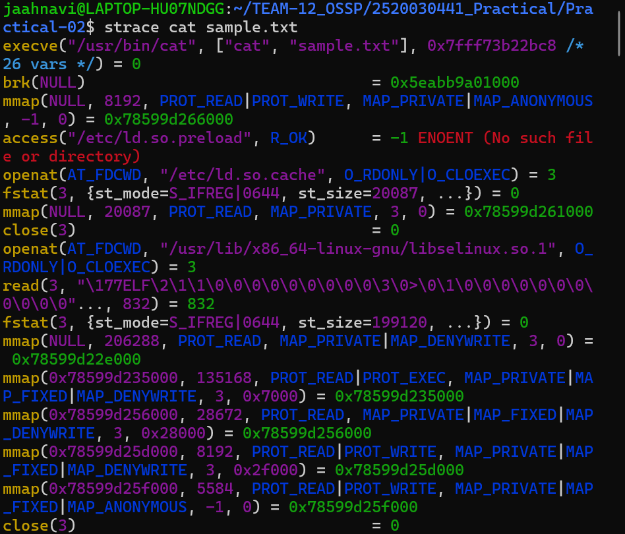
Observation:
The fork() system call creates a child process from the parent process. Both processes have separate PIDs, while the child's PPID corresponds to the parent's PID. The process state changes during execution: the child is Running while executing, may enter a Waiting/Sleeping state during sleep(), and becomes Terminated after completing its execution. The parent enters a Waiting state while waiting for the child using wait(), and continues execution after the child terminates. The ps, top, and /proc commands can be used to observe these process states.

